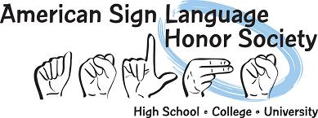

POINT BREAKDOWN
Below is a list of different ways you may earn your 15 Points for American Sign Language Honor Society for Community Service and Deaf Events.

What to do | Community Service/Deaf Event | Points earned
Attend Deaf Coffee (1/2 Hour) | Deaf Event | 1
Attend Deaf Coffee (1 Hour) | Deaf Event | 2
Attend ASL Show | Deaf Event | 4
Participate in ASL Show | Community Service | 6
ASL Club Member | Community Service | ½ for each meeting
Pass out papers for teacher in class | Community Service | ¼
Attend Deaf Performance | Deaf Event | 4
Attend Deaf Expo | Deaf Event | 5
Tutor another ASL Student (1/2 hour) | Community Service | 1/2
Help your ASL teacher (1/2 hour) | Community Service | 1/2
Other Activities per teacher’s announcement | Deaf Event/Community Service | Varies by teacher plan
Other events and activities can be counted, but please speak with Ms. Mallory first.

